Modern Science: Investigating the Case of the Aral Sea – 5th– 6th Grade

Objectives:
- Students will understand that some lakes are salty and others are freshwater.
- Students will understand the effect pollution can have on the surrounding environment.
- Students will understand how the environment changes over time.
- Students will understand how humans interact with the environment and how the environment affects humans.

Standards:
5.4.4 Explain that in any particular environment, some kinds of plants and animals survive well, some do not survive as well, and some cannot survive at all.
5.4.5 Explain how changes in an organism’s habitat are sometimes beneficial and sometimes harmful.
5.5.7 Explain that predictions can be based on what is known about the past, assuming that conditions are similar.
6.3.8 Explain that fresh water, limited in supply and uneven in distribution, is essential for life and also for most industrial processes. Understand that this resource can be depleted or polluted, making it unavailable or unsuitable for life.
6.3.16 Explain that human activities, such as reducing the amount of forest cover, increasing the amount and variety of chemicals released into the atmosphere, and farming intensively, have changed the capacity of the environment to support some life forms.
6.4.8 Explain that in all environments, such as freshwater, marine, forest, desert, grassland, mountain, and others, organisms with similar needs may compete with one another for resources, including food, space, water, air, and shelter. Note that in any environment, the growth and survival of organisms depend on the physical conditions.
6.7.2 Use models to illustrate processes that happen too slowly, too quickly, or on too small a scale to observe directly, or are too vast to be changed deliberately, or are potentially dangerous.

Approximate Length: 45-50 minutes

Materials Needed:
Transparencies showing how the Aral Sea has changed with time.
Small paper or plastic cups
2-3 liters of water & pitcher
Salt
Bag (or hat or other container) that is not see through
Different colored sheets of construction paper (9 sheets of red construction paper, 1 sheet of blue, 1 sheet of green, 1 sheet of yellow) folded into squares of 8 and cut out

About the Lesson:
This lesson may look and sound complicated, but it’s actually quite simple, and the activities are fun for kids to do. This lesson teaches students scientific principles by exploring the degradation of the Aral Sea. Teachers will probably wish to give students a very basic background on the Aral Sea. The following information will probably be enough, but if the teacher wants a deeper background, she/he can check out the background page located near the end of the lesson plan.

The Aral Sea:
The Aral Sea is located in Central Asia between Kazakhstan and Uzbekistan. It is actually a lake, but because the water inside is salty like the ocean, it was called a sea. It used to be the 4th largest lake in the world, but has been shrinking for over 40 years because farmers were taking a lot of water from the lake to bring to their cotton fields. Now, there is almost nothing left of the lake, and if the same conditions continue, the lake will soon be completely gone. Human actions have changed the environment drastically. Because there is much less water to moderate temperatures, winters have become much colder and summers much hotter.

The Aral Sea region had many unique fish, plants, and animals. As the water has gone down, the amount of salt in the water has increased making it too salty for many of them to live there anymore. Good, clean water is important for plants and animals to survive. Many fish, plants, and animals have died because the water is too salty and dirty. Like the dinosaurs, some species near the Aral Sea have become extinct.

To make matters worse, the government, farmers, and other people have been dumping garbage and harmful chemicals in the Aral Sea and the area around it. This means that people living close to the Aral Sea are much more likely to get sick because of the pollution and improper waste removal. People living there have 9 times the rate of cancer as other people in their countries.

Procedures:
- Using a globe or a map, show students where the Aral Sea is. Explain that the Aral Sea once used to be the 4th largest lake in the world, almost half the size of England. Explain that the Aral Sea is actually a lake, not a sea, and that it is a salty lake, not a freshwater lake.
- Show students transparencies (attached below) of the sea and see if they can identify changes and differences between the pictures. (What differences do you notice? What parts of the Aral Sea don’t have water now? How has the shape changed? Any changes to color?)
- You may also wish to pull up NASA’s excellent website on the Aral Sea, http://earthobservatory.nasa.gov/Features/WorldOfChange/aral_sea.php, so that students can see how the Aral Sea has changed year by year from 2000-2011.
- To show students how salt content has increased in the Aral Sea, perform the following activity:
  - To replicate the salinity statistics given in the background information (for the teacher), take 1 liter of water and pour in 2 tsp. of salt. Mix together and pour in little cups, one for each student. Have students taste the water and explain that is what the water was like before people started ruining the Aral Sea. (What does the water taste like? Can you taste the salt?) Explain that while the water may taste a little salty to us, a little bit of salt in the water is good for some types of fish, animals, and plants.
  - Next, take 1 liter of water and pour in 9 tsp. of salt (the average amount in the Aral Sea now). Mix together and pour in little cups, one for each student. Now, have students taste the new water and see if they can tell a difference. (Does it taste more or less salty than before?) Explain that as people blocked rivers and took more and more water for their fields, the water in the sea became saltier and saltier. It became too salty for many of the fish, animals, and plants, so they started to become sick and die.
  - If you want to take the activity one step further, take 1 liter of water and pour in 19.5 tsp. of salt (the equivalent to the salinity levels in the most salty southern areas of the Aral Sea). Mix together and pour in little cups, one for each student. Have students taste the water and see what they think. (What would water like this do to the plants, fish, and animals living in the area? How would it change the environment?)
- To show students the health impacts pollution has on the people living near the Aral Sea, do the following activity with students:
  - This may be a good time to connect the Aral Sea to students’ own environment. Explain that because farmers and people near the Aral Sea were dumping garbage and chemicals everywhere without throwing them away properly, people living there started to get sick. Explain to students that this is one of the reasons why students shouldn’t litter, and why people should dispose of waste properly. (What are some environmental problems in your neighborhood? Have you seen areas nearby where environmental damage is occurring?)
  - Tell students that people living by the Aral Sea are 9 times more likely to get cancer than other people. In order to illustrate this to students, play the following game with them.
  - Have all the squares of paper in a bag or non-see-through container so that students can’t see the colors. There should be 8 squares of blue, 8 squares of green, 8 squares of yellow, and 72 squares of red. (You can have fewer squares, just keep the proportions the same. Red should have 9 times the number of squares of any other color.)
  - Divide students into roughly equal groups of four and assign each group a color. Tell students that you will take the bag around, have them close their eyes, and draw out one square. If the square is in the group’s color, they get a tally mark on the board under their group name. More points are bad in this game!!! The more points you get, the more likely you are to get sick. (Or you could explain it as each time their color is drawn, they get sick.)
  - Make sure each student gets at least one turn to draw a square. Make tally marks on the board as the squares are drawn. Students should come to see that the red group is getting sick much more often than any other group (about 9 times more often), because they’ve been exposed to a lot of pollution.
  - Have students discuss what this means and what they can do to reduce pollution.

Further Resources:
Unimaps – info on Aral Sea pollution
http://unimaps.com/aral-sea/index.html

NASA photos
http://earthobservatory.nasa.gov/Features/WorldOfChange/aral_sea.php

http://earthobservatory.nasa.gov/IOTD/view.php?id=1396

Aral Sea background
http://orexca.com/aral_sea.shtml
Background
The Aral Sea is located in the central Asian countries of Uzbekistan and Kazakhstan. Once the world's fourth largest lake, the mighty Aral Sea is now almost gone. The sea has been shrinking for the last 40 years.
The Aral Sea is an inland salt-water sea with no outlet. It is fed by two rivers, the Amu Darya and Syr Darya. The fresh water from these two rivers held the Aral's water and salt levels in perfect balance.
Then, in the early 1960's, the Soviet government decided to make the Soviet Union a large exporter of cotton. Large dams were built across both rivers and many smaller canals were created to water the cotton fields. Over the next 30 years, the Aral Sea experienced a severe drop in water level, its shoreline receded, and its salt content increased. The marine environment became so salty and polluted; it killed many of the Aral Sea’s plants and animals. As the marine life died, the fishing industry suffered.
By 1990, as a result of the continuing water diversion, the shrinking Aral Sea divided in two and its salinity increased from 10 grams (2 tsp) per litre to 45 (9 tsp). In some parts of the south Aral, salinity tops out at 98 g (19.6 tsp) per litre as of 2001. Average seawater salinity is 33 g (6.6 tsp) per litre. The once thriving fishing industry has been destroyed along with the fish and most of the flora and fauna. Salt pans and contaminated runoff lakes have appeared, and winters have become harsher and longer, summers hotter and shorter.
Today, towns that used to be fishing towns are now desert towns more than 50 miles from the Aral Sea. Ships were left to rot in the sand. The sea has shrunk to two-fifths of its original size and now ranks about 10th in the world. The water level has dropped by 52 feet and the volume has been reduced by 75 percent, a loss equivalent to the water in both Lakes Erie and Huron.
The ecological effect has been disastrous and the economic, social and medical problems for people in the region catastrophic. The cotton fields flourished, but farmers had to use massive amounts of chemical pesticides. Of the region's 73 species of birds, 70 of mammals and 24 of fish, most have either perished or moved on. Roughly 20 fish species in the Aral Sea are now extinct, unable to survive the toxic, salty sludge. Drinking water supplies have dwindled, and the water is contaminated with pesticides and other agricultural chemicals as well as bacteria and viruses.
The area is now constantly subject to toxic duststorms and desertification, the people of the area have 9 times the world average rate for throat cancer, and infant/maternity mortality is the highest in all of the former Soviet Union's republics. Respiratory complications, tuberculosis and eye diseases are also rising alarmingly.
The Uzbek government has little concern for the Aral Sea, so the southern portion will mostly likely completely disappear in a few years. The Kazakh government has implemented some policies to try to protect the Aral Sea, so the northern part may stand a chance.

Name: _________________________________________________ Date: _____________

[Worksheet Title]

[Directions]

[Content]

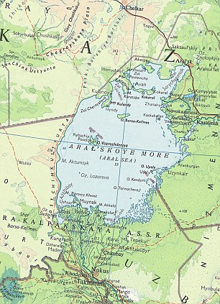
Map of the Aral Sea - 1967
Map of the Aral Sea – 2007

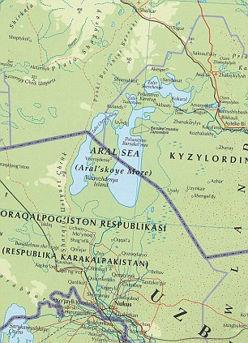

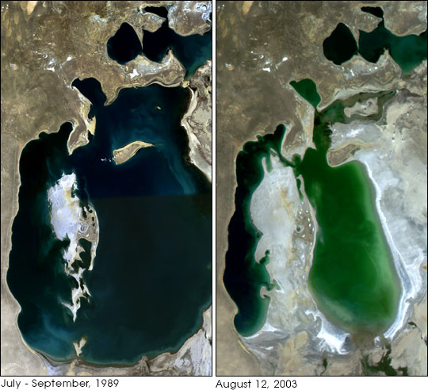
NASA Satellite Images of the Aral Sea – 1989 and 2003

